
Fund School Vouchers
CENTRE
FOR
CIVIL SOCIETY

BOARD OF TRUSTEES
Ashish Dhawan, Chairman
Arun Duggal
Adit Jain
Premila Nazareth
Ajay Narottam Shah
Parth J Shah

BOARD OF SCHOLARS
Isher Judge Ahluwalia
Swaminathan Aiyar
Jagdiah Bhagwati
Surjit S. Bhalla
Meghnad Desai
Deepak Lal
Shreekant Gupta
Kirit Parikh
Urjit Patel
Nirvikar Singh
Suresh Tendulkar
Leland B. Yeager

A-69 Hauz Khas
New Delhi 110016
Voice: 2653 7456/2652 1882
Fax: 2651 2347
ccs@ccs.in
www.ccs.in
www.schoolchoice.in
www.jeevika.org
www.azadi.me

The School Choice Campaign is currently providing vouchers to 808 children and helping them escape the crumbling government education system. For these poor students, vouchers have proven to be a tool of empowerment allowing them access to schools offering better quality education and enabling them to hold these schools accountable for performance.
Please support these children by funding their school voucher at INR 4,000 per student which will guarantee them one more year of quality education. To support these children fill this form and send along with the cheque or mail it to schoolchoice@ccs.in
Under the School Choice Campaign you can fund two voucher projects – Delhi Voucher Project launched in 2007 and School Voucher for Girls in 2009.

BOARD OF TRUSTEES
Gurcharan Das, Chairman
Ashish Dhawan
Arun Duggal
Adit Jain
Premila Nazareth
Ajay Narottam Shah
Parth J Shah
O P Vaish

BOARD OF SCHOLARS
Isher Judge Ahluwalia
Swaminathan Aiyar
Jagdiah Bhagwati
Surjit S. Bhalla
Meghnad Desai
Deepak Lal
Shreekant Gupta
Kirit Parikh
Urjit Patel
Nirvikar Singh
Suresh Tendulkar
Leland B. Yeager

K-36 Hauz Khas Enclave
New Delhi 110016
Voice: 2653 7456/2652 1882
Fax: 2651 2347
ccs@ccs.in www.ccs.in
www.schoolchoice.in
www.jeevika.org
Delhi Voucher Project: Under this project 408 students from 68 wards in Delhi were awarded vouchers. We received 120,000 applications! An assessment of the program demonstrated that voucher children have academically outperformed those still studying in government schools. More importantly for the future of these children, it indicated close to a 20% increase in the involvement of parents in their education after receiving vouchers.
School Voucher for Girls: This project funds the education expenses of 400 girl children from a poor minority community for four years. By targeting this traditionally disadvantaged group our project seeks to address gender-based discrimination in education through vouchers.
To support children’s Right to Education of Choice donate toward the education of: (please put ‘X’ against your choice):
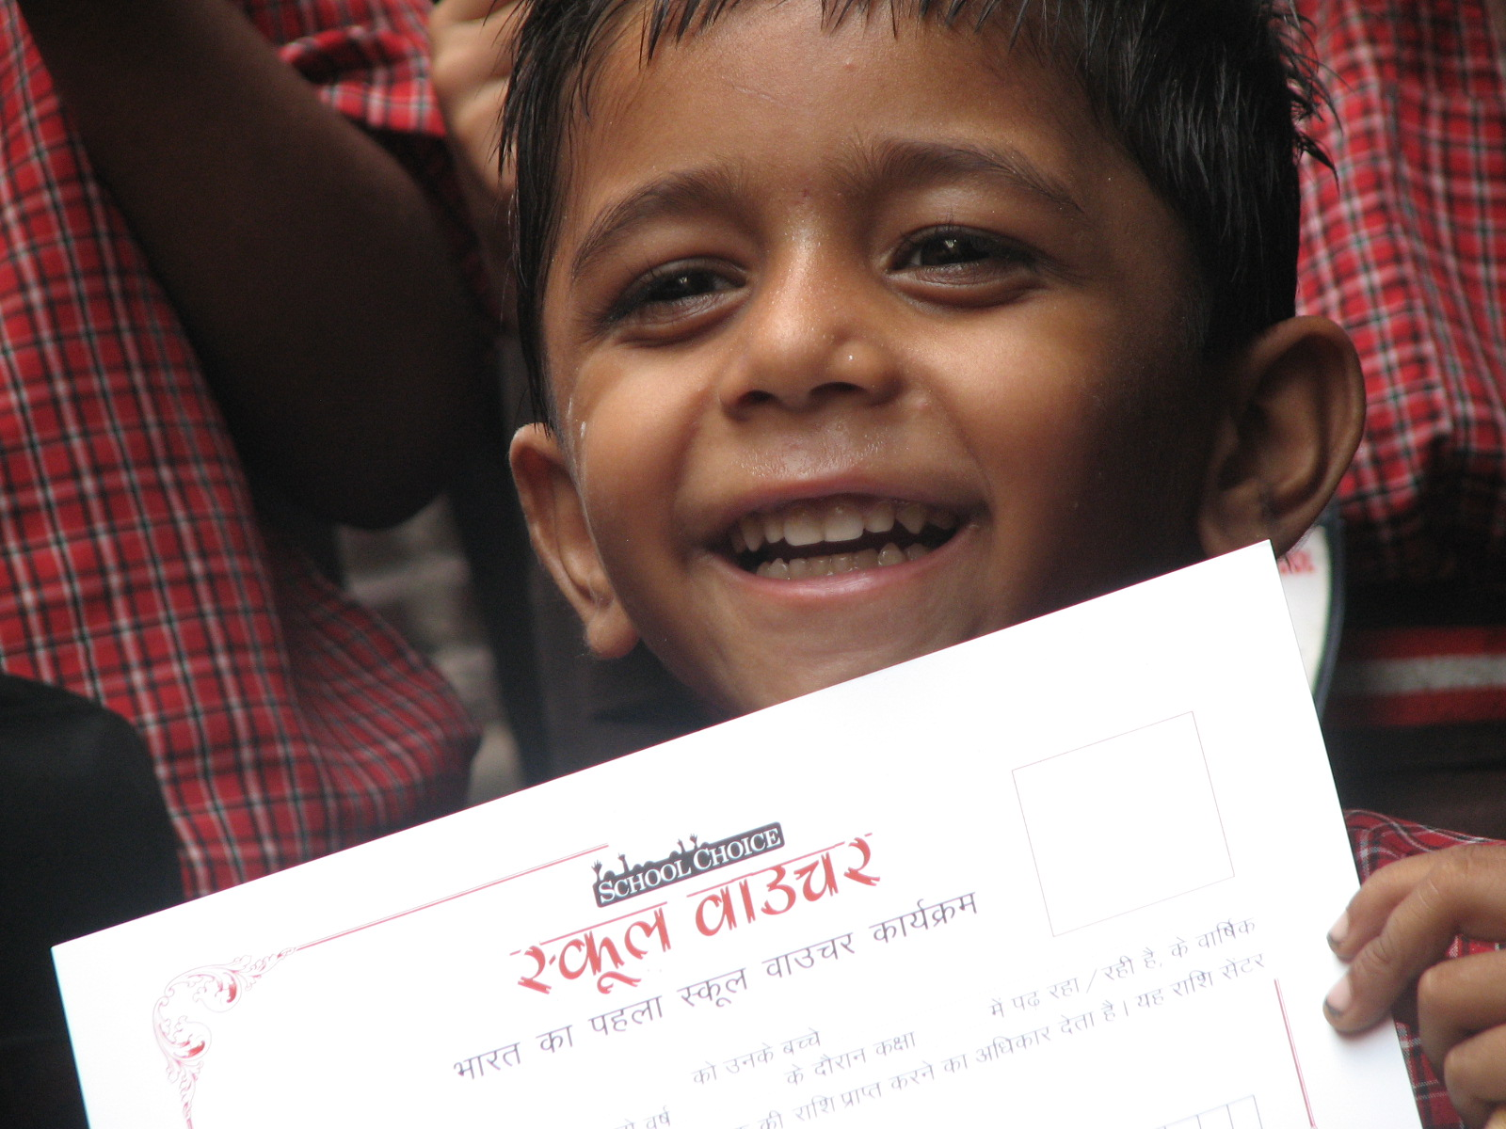
[ ] 1 child for 1 year: INR 4000 ($84.00)
[ ] 1 child for 2 years: INR 8400 ($175.00)
[ ] 1 child for 3 years: INR 13250 ($275.00)
[ ] 1 child for 4 years: INR 18,600 ($388.00)
[ ] Rs/$ _______ to be utilized as considered
appropriate for the School Choice Campaign

You can make a donation by:
- Sending a cheque
- Wire transfer/Net transfer

Send your cheque in favor of :
CENTRE
FOR
CIVIL SOCIETY

BOARD OF TRUSTEES
Ashish Dhawan, Chairman
Arun Duggal
Adit Jain
Premila Nazareth
Ajay Narottam Shah
Parth J Shah

BOARD OF SCHOLARS
Isher Judge Ahluwalia
Swaminathan Aiyar
Jagdiah Bhagwati
Surjit S. Bhalla
Meghnad Desai
Deepak Lal
Shreekant Gupta
Kirit Parikh
Urjit Patel
Nirvikar Singh
Suresh Tendulkar
Leland B. Yeager

A-69 Hauz Khas
New Delhi 110016
Voice: 2653 7456/2652 1882
Fax: 2651 2347
ccs@ccs.in
www.ccs.in
www.schoolchoice.in
www.jeevika.org
www.azadi.me
“Centre for Civil Society ”
Addressed to:
Centre for Civil Society
A-69, Hauz Khas
New Delhi - 110 016
Tel : 011 2653 7456, 011 2652 1882
OR Wire Transfer/Net Transfer to
HDFC Bank Ac No. 00321000114144,
SDA Branch, New Delhi
All donations are tax exempt U/S 80 G of IT Act

Contact details:
Name :
Address :
City : |  | Pin :
Phone no. :
Mobile :
Email :
PAN number:*
Cheque/DD No. :
Drawn on :
*Specifically for Indian citizens

For further information please visit www.schoolchoice.in. We count on your support to better education opportunities for all children in India.

